2. Now we must figure out which number of terms to use in a final prediction. We need to

tune this parameter. Use 10-fold cross-validation to train models and compute MSPE

for values of nterms from among 1, 2, 3, 4, and 5, maintaining max.terms=5. Be sure

to train each version of the model on each fold so that the comparison across the tuning

parameters is easy.

(a) **Report the matrix of MSPEs from CV.** (There should be 10 rows and 5

columns)

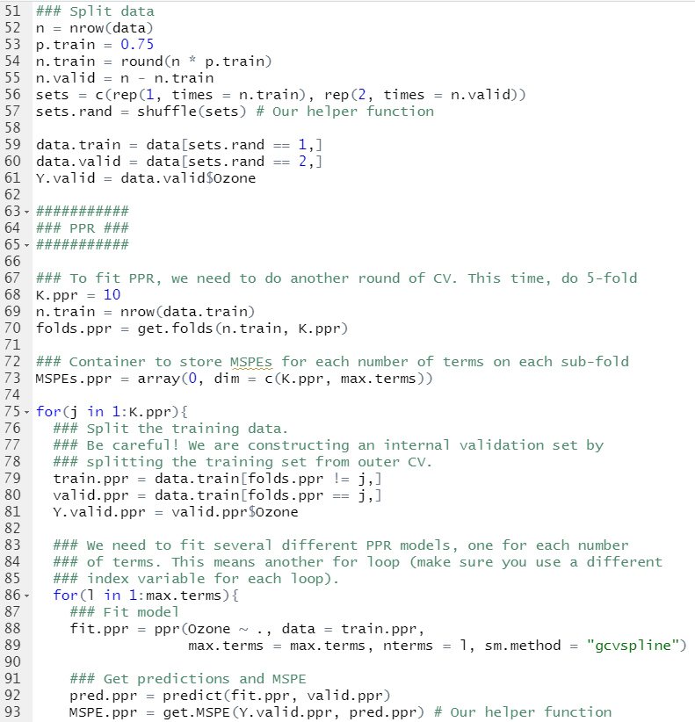

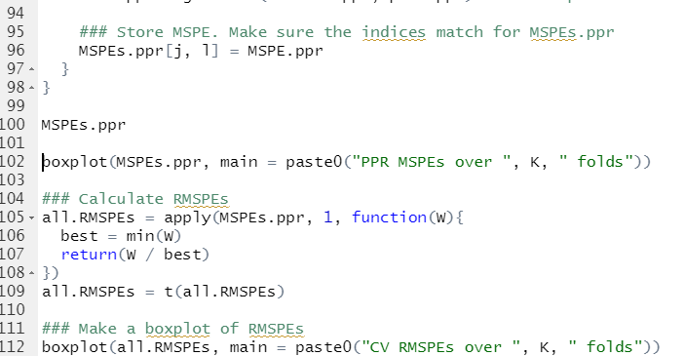

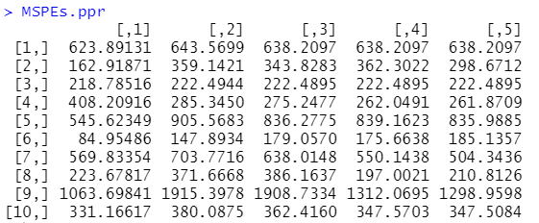

i. Comment on any consistent patterns you see in the comparison among numbers

of terms. Specifically, are there one or more values that seem much

better than others?

* Generally it looks like when nterms is 3, it has the smallest MSPE

(b) **Create and show the side-by-side boxplots of these 10 MSPEs for each**

**number of terms (5 boxes)**

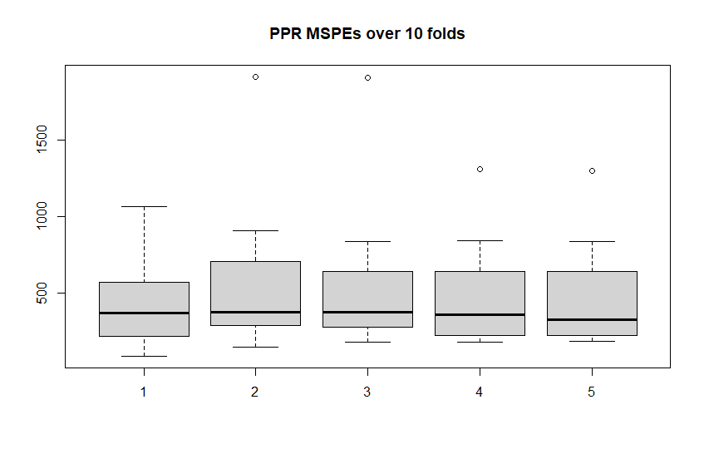

(c) **Repeat using relative MSPE**

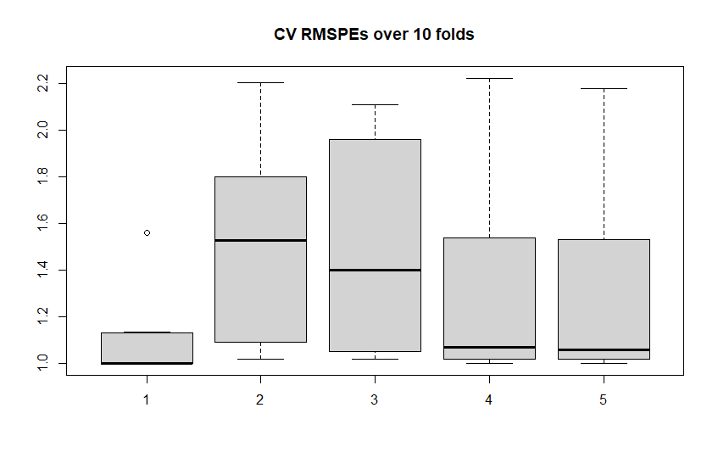

(d) Based on what you have seen, **how many terms would you use?** If there is

no clear winner, then choose the least complicated model than is among the top

models.

I would use 1, because it’s clearly better than other number of terms.